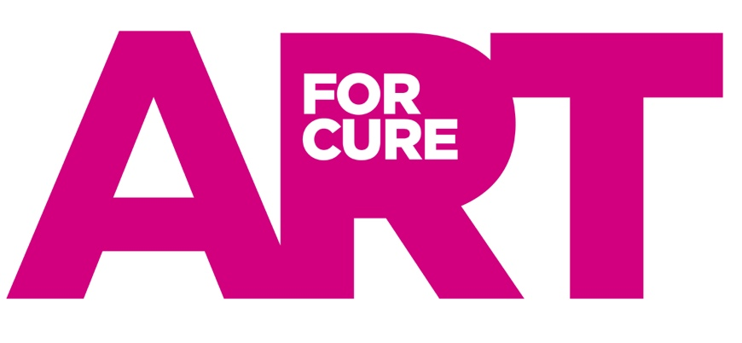
ONLINE GALLERY — TERMS FOR ARTISTS

We'd love you to join the Art for Cure Online Gallery. In just over six months, the gallery has generated strong sales, and we're now growing our sculpture selection and building a dedicated marketing, PR and national coverage effort to support it.
Buying art while supporting a charity close to so many people's lives is a genuinely original idea, and we're excited about the exposure this is bringing both in the art and gifting world and with our existing audience. Below is a summary of how the gallery works, and what we each take on as part of it.
HOW IT WORKS
- Your Gallery Page — Your work sits on a permanent page on the Art for Cure website, with your photo, biography and available pieces — this personal connection makes a real difference to how art sells online. Do send us any short films or videos too; they're great for social media.
- Submitting Your Work — Once you're ready to take part, we'll set you up with a login to our artist portal at submit.artforcure.org.uk. From there, you can upload your biography and add new pieces yourself whenever you have fresh work available, without needing to go through us each time.
- When a Piece Sells — We're notified automatically and will pass on the buyer's details straightaway. Please get in touch with the buyer within 24 hours to arrange delivery, collection or lead times, and keep us posted until the piece has safely reached them — this is what triggers your payment.
- Payment & Commission — We handle all sales and payments centrally. Buyers pay in full at the point of sale, though a 50% deposit can be arranged for pieces with a longer lead time. We pay you at the end of each month, less our commission: 50% on paintings, prints and ceramics, 30% on sculpture.
- Delivery & Collection — Delivery is arranged directly between you and the buyer, who pays any delivery fee to you. We'd also encourage collection in person where possible — it's often a lovely moment for a buyer to meet the artist — but just let us know if you'd rather not offer this.
- Photography — Clear, well-lit photographs from multiple angles make a real difference to how a piece sells online, especially for sculpture. Good photography is one of the simplest ways to help your work stand out.
- Packaging — Once you're confirmed, we'll send you Art for Cure thank-you postcards and self-adhesive labels to include with each piece.
- Keeping Stock Available — Please try to keep a minimum of three pieces (paintings and ceramics) or three sculptures available at any time — do let Belinda know if that's not possible. When something sells, we'd love a replacement as soon as you're able.
- Selling Elsewhere — You're welcome to show the same work elsewhere, but please tell us as soon as it sells, or an edition is complete, so we can avoid a piece being sold twice.
- Marketing & PR — We promote the gallery and our artists through our audience, media contacts and PR channels, and we're always looking for new ways to raise your profile alongside ours.
GETTING STARTED
If you'd like to take part, email belinda@artforcure.org.uk and we'll talk through your collection and get you set up on the portal.
We'd be thrilled to have you on board — please don't hesitate to get in touch with any questions at all.
belinda@artforcure.org.uk / 07815 061132
14 September 2026

